Patient Controlled Medical Records and eReferrals across Affinity Domains

February 11, 2005

Adrian Gropper
52 Marshall St.
Watertown MA 02472

This document and attachments are to be filed as a provisional patent application in advance of upcoming public disclosure. The descriptions in these disclosures relate to two previous provisional filings but may also include material that supports new claims. These disclosures should not be used in a way that jeopardizes the effective dates of the original patents.

BACKGROUND

An Affinity Domain is commonly described as people and the information systems they employ that have agreed to policies in advance that address governance and operational structure, privacy, security, normalized patient identification and coded vocabularies. Although this kind of formal prearrangement is reasonable between institutions, it is inconvenient and unmanageable for individual patients (and even doctors) that want to deal with new entities and individuals that may not have pre-established an Affinity Domain relationship.

The methods described in the two referenced US Patent applications and the current disclosure are a practical solution to the problem an individual faces when trying to communicate private medical information to virtual strangers. As such, they are useful in electronic referrals – eReferrals – over the Internet.

A major benefit of the solution we describe is the separation of technology from policy. This enables a substantially uniform technology (MedCommons) to support a multiplicity of Affinity Domains with different policies and to be useful even to individuals who often make decisions about the Affinity Domains they trust on a case-by-case and day-by-day basis.

OVERVIEW OF METHODS

The solution combines a central enterprise that is relatively policy neutral with technology accessible over the Internet that is accessible to enterprises that can agree to participate in a single affinity domain in advance as well to individuals (and other enterprises and affinity domains) that wish to interact with the established affinity domain.

The access technology, as previously described in the provisionals we reference is a gateway information system that is controlled by the host enterprise or user. Alternatively, the functions of this gateway are managed by use of a secure Web browser.

In the preferred embodiment, the access gateway is Open Source Software that may be more easily analyzed, trusted, and integrated into an enterprise’s information systems and devices.

As previously described in the two provisionals, the Central System manages security and activity logs and encryption keys so as to provide a policy-neutral infrastructure for implementation of multiple affinity domains and interaction with individuals. For example, MedCommons has adopted IHE-XDS, ASTM-CCR and HIPAA as the affinity domain neutral foundation for technical interoperability and legal redress.

Two novel methods are claimed:

1 – To protect the user’s privacy relative to medical information that have stored on behalf of an individual user, the central system offers users the option of verifying their own presence of the point when the information is requested from the central, policy-neutral repository service (MedCommons). One simple way to do this is to require use of a Debit Card to initiate the transaction disclosure or otherwise identify the presence of the individual at the point of use.

A related method to support trusted use of centrally stored information across multiple affinity domains under patient control is to provide a means for the patient to set and communicate a unique PIN number to the recipient in a manner that is complementary to the central system. For example, a telephone call directly between the patient and their intended user can communicate a PIN that allows access to information managed by the central system.

2 – To establish patient control while maintaining a policy neutral infrastructure, the central system allows patients to manage their own identity independent of any particular affinity domain. The central system ensures uniqueness of ID’s but does not restrict the patient’s choice of ID and when to use it. One simple way to do this is to provide the patient with technology and forms that allow them to request that a particular ID that hey control is linked or associated with their identity as known and controlled by an affinity domain. This innovation moves the problem of identity management and information aggregation away from the affinity domain and into the control of the patient. This then is the second method that allows the central system to provide a policy-neutral technical infrastructure.
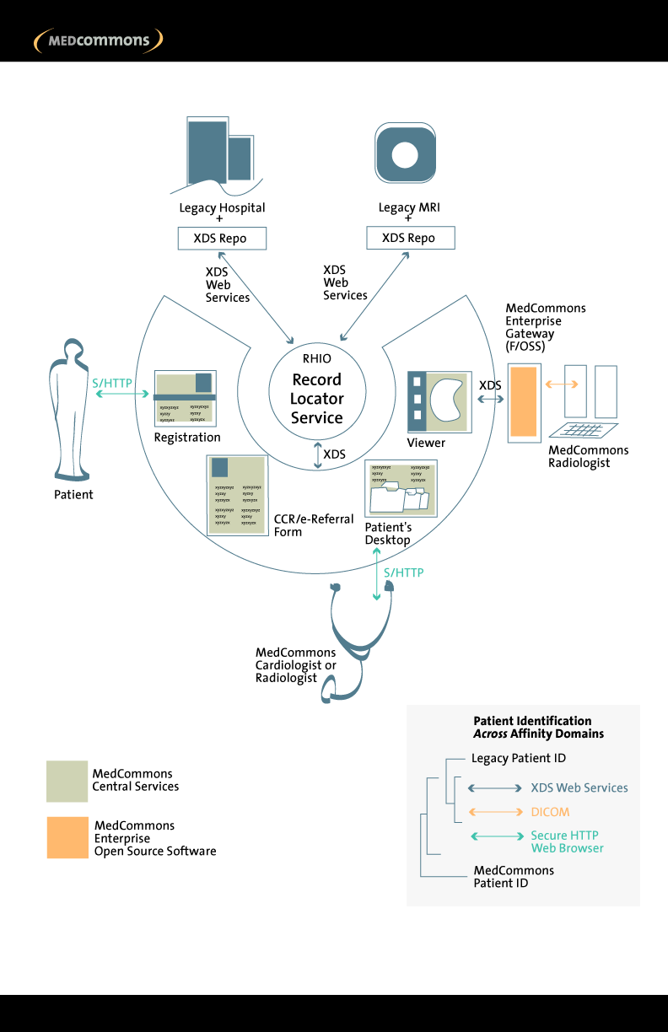
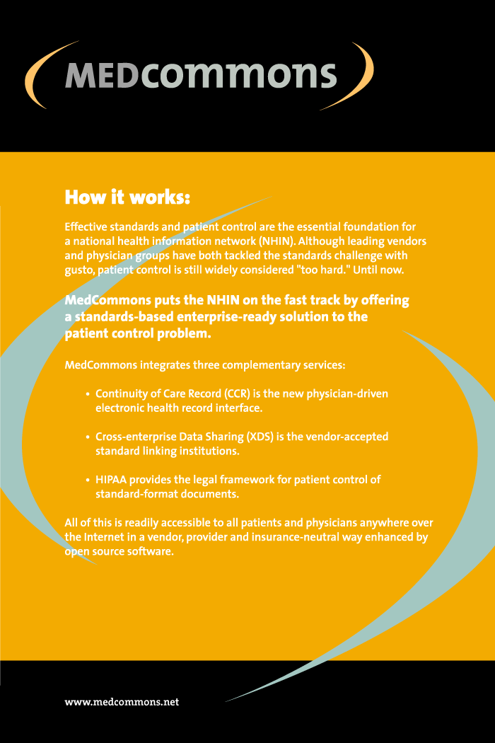
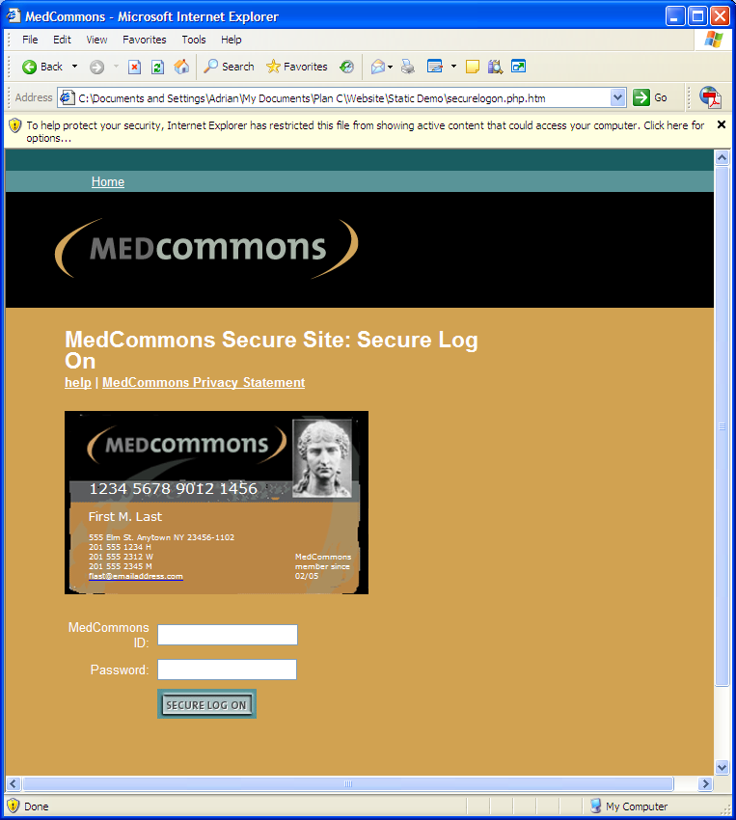
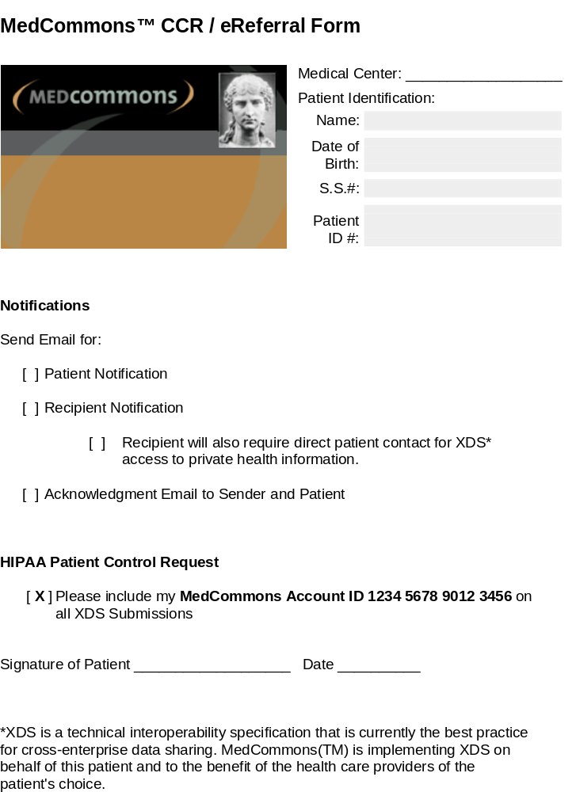


University of Massachusetts Quinnobbiquin Medical Center
REQUEST TO RESTRICT THE USE OR DISCLOSURE OF PATIENT INFORMATION
University of Massachusetts Quinnobbiquin Medical Center Patient Identification:
Name:
Date of Birth:
S.S.#:
Patient ID #:

I request that University of Massachusetts Quinnobbiquin Medical Center restrict the use or disclosure of my health information in the ways described below:
Restricted Information: 
How it works:
Effective standards and patient control are the essential foundation for a national health information network (NHIN). Although leading vendors and physician groups have both tackled the standards challenge with gusto, patient control is still widely considered "too hard". Until now.
MedCommons puts the NHIN on the fast track by offering a standards-based enterprise-ready solution to the patient control problem.
MedCommons integrates three complementary services:
- Continuity of Care Record (CCR) is the new physician-driven electronic health record interface.
- Cross-enterprise Data Sharing (XDS) is the vendor-accepted standard linking institutions.
- HIPAA provides the legal framework for patient control of standard-format documents.
All of this is readily accessible to all patients and physicians anywhere over the Internet in a vendor, provider and insurance-neutral way enhanced by open source software.
 | Please provide a description of the information that you want restricted:
[ X ] | All IHE-XDS* forms and records
[ ] | other:

 | Restriction Request: Are you requesting a limitation on the use of the information, disclosure of the information or both the use and disclosure of the information?
[ X ] | Include my MedCommons Account ID 1234 5678 9012 3456 on XDS Submissions
[ ] | other:

Personnel with Access: Please outline the personnel permitted to access your information.
I UNDERSTAND THAT I MAY ONLY REQUEST RESTRICTIONS ON THE USE AND DISCLOSURE OF INFORMATION FOR THE PURPOSES OF TREATMENT, PAYMENT, ADMINISTRATIVE FUNCTIONS OR WITH INDIVIDUALS INVOLVED IN MY CARE AND THAT University of Massachusetts Quinnobbiquin Medical Center CANNOT ACCEPT RESTRICTION THAT APPLY TO DISCLOSURES REQUIRED BY LAW OR OTHER APPLICABLE EXCEPTIONS.I UNDERSTAND THAT University of Massachusetts Quinnobbiquin Medical Center IS NOT REQUIRED TO AGREE TO THIS RESTRICTION BUT IF IT DOES IT MAY NOT USE OR DISCLOSE INFORMATION IN WAYS THAT WOULD BE IN VIOLATION OF THE ABOVE OUTLINED RESTRICTIONS, EXCEPT THAT, IF IT IS NECESSARY TO DISCLOSE OR USE RESTRICTED INFORMATION IN AN EMERGENCY SITUATION
I UNDERSTND THAT University of Massachusetts Quinnobbiquin Medical Center MAY TERMINATE ITS AGREEMENT TO THE RESTRICTION, EXCEPT THAT SUCH TERMINATION IS ONLY EFFECTIVE WITH RESPECT TO PROTECTED HEALTH INFORMATION CREATED OR RECEIVED AFTER VUMC HAS SO NOTIFIED ME OF THE TERMINATION.
I ALSO UNDERSTAND THAT I MAY TERMINATE THIS RESTRICTION BY WRITING TO THE ADDRESS PROVIDED BELOW.
Signature of Patient/: _______________________________________ Date: _________
Legal Representative
Relationship to Patient: ____________________________
(A copy of this signed form will be provided to the patient)
To revoke this restriction, please send a written request with a copy of this form to the address below:
University of Massachusetts Quinnobbiquin Medical Center
Privacy Office AA 1434
San Francisco, CA 87532-2202
If you have any questions please call the UMC Privacy Office 677-555-4594.
*XDS is a technical interoperability specification that is currently the best practice for cross-enterprise data sharing. MedCommons(TM) is implementing XDS on behalf of this patient and to the benefit of the health care providers of the patient's choice.

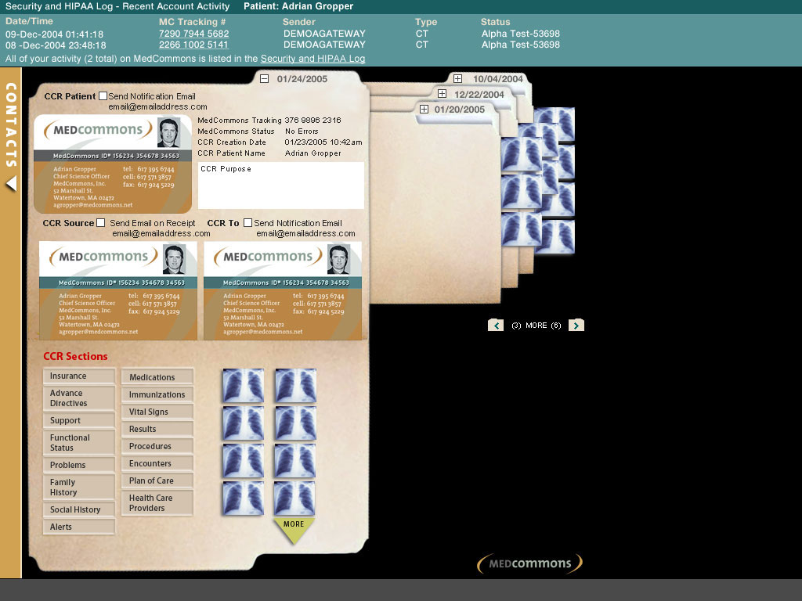
MedCommons Privacy Policy
v0.2
Effective Date: February X, 2005.
DRAFT: This policy is released for public comment and is subject to change prior to the initiation of confidential patient services.
MedCommons has prepared this privacy statement to demonstrate our firm commitment to your privacy and your security as you visit and use the services provided by this site.
How we protect your privacy and your information.
1. | MedCommons is committed to giving you, the patient, control over your medical data to the fullest extent permitted by law. Some of the ways we provide patient control include
 | a. | MedCommons uses the existing HIPAA privacy law as the foundation for patient control.
 | b. | MedCommons creates a modified HIPAA Restrictions Form to make it easy for the patient to request copies of certain standard documents from their health care providers.
 | c. | MedCommons interprets patient control to include the right to conveniently view, copy, store, add and remove health care-related documents before sharing them with the health care provider of your choice.
 | d. | MedCommons preserves your legal options and facilitates medical records interchange by maintaining the integrity of documents signed by your health care providers. You can, however, remove entire documents from referral folders prior to transmission to a health care provider.
 | e. | MedCommons does not alter the contents of your signed or unsigned health care documents in any way. You and your designated health care providers are the only parties that can see, add or remove documents from your account.
 | f. | MedCommons maintains secure logs of all account activity as required by law. This allows you, the patient to review which health care providers (individuals or enterprises) have viewed or added documents to your repository account.
 | g. | MedCommons will delete documents only with the patient’s permission. Deletion activity is managed and logged as required by law.
 | h. | MedCommons will not review, aggregate, sell or divert a patient’s private health information except as might be required by law.
 | i. | Although MedCommons employs encryption technology and formal security practices to protect patient privacy, patients may choose to further encrypt their private health information with keys that are not available to MedCommons at all. Such patient-controlled encryption is allowed by MedCommons but patients must acknowledge the increased risk of information loss and potential difficulty in emergency access if they choose to control their own encryption.
 | j. | MedCommons cannot and does not maintain control of documents once they are passed to a health care provider or other destination designated by the patient. The MedCommons logs will not reflect any activity related to the documents once they are in the possession of the provider.
 | k. | MedCommons can be used for provider-to-provider communications that do not directly involve the patient. These communications will be supported by MedCommons in a manner that preserves the accountability of the providers and the legal rights of the patient. The patient will be able to review the logs of such provider-to-provider communications of their personal and private health information. MedCommons may make copies of documents passed during provider-to-provider communications on behalf of the patient and store these copies automatically in the patient’ repository account.
 | l. | MedCommons can be used for provider-to-provider, provider-to-patient and patient-to-provider communications. Notification of the recipient that there are documents accessible to them can be made by MedCommons at the request of the patient or a provider authorized by the patient.. Notifications are considered insecure and MedCommons encourages users of the notification features to carefully check these communications for inadvertent private health information. MedCommons access restrictions and privacy policies apply to health care documents and not to the notification that documents might be available.
 | m. | MedCommons will not release documents or any of the information contained therein unless explicitly requested by the patient or required by law.
 | n. | Access to documents in the patient’s repository account is managed by MedCommons on the patient’s behalf. At the discretion of the sender, access to a document may be granted if the recipient is
 |  | 1. | affiliated with an enterprise that the sender accepts as being trustworthy
 |  | 2. | granted access by the patient in person
 |  | 3. | granted access remotely by the sender through a direct communication of a password or PIN that is not known or accessible to MedCommons
2. | The information that we collect while visiting this site is used
 | a. | To protect your account from unauthorized access
 | b. | For the processing of your requests and service to your account
 | c. | To improve and enhance our services to our customers
3. | We use cookies to enhance the user’s experience on our website. A cookie is a small file placed on your hard disk by a Web page server. Cookies cannot be used to run programs or deliver viruses to your computer. Most browsers are initially set to accept cookies. If you'd prefer, you can set yours to refuse cookies. However, it is likely that most areas of this site will not function properly if you do so.
4. | This website makes links to other websites, however, MedCommons is not responsible for the privacy practices of those web sites. This MedCommons Privacy Policy applies solely to information provided by this website.
5. | We will not and do not provide our client list to a third party..
The policies and practices described in this MedCommons Privacy Policy are subject to change. Any revisions to this MedCommons Privacy Policy will be posted 30 days prior to its effective date. Material changes will be prominently posted on the home page or by notification to registered users via email. We strongly encourage you to review this statement periodically. By using this site you acknowledge acceptance of this privacy statement at the time of use.
Registration and Verification of Patients and other Users who will be accessing PHI.
- Users establish a Temporary ID which is, by default, their Email and assigned a 4-digit Temporary Password. This stage is actually optional and merely a convenience to people who want to demo or to start the registration process online. This part of the registration process could be done by a provider or family member on behalf of a luddite patient. Demos are designed to discourage the persistent storage of PHI other than Contact info. Users will be strongly encouraged to supply a photograph that will appear on their HIPAA Restrictions Form. This will make it less likely that someone can impersonate them when dealing with providers.
- The patient begins the Verification process by acknowledging whatever we require as the MedCommons Terms of Use and agreeing to pay the Verification fee ($5). Their credit card is charged. This verifies that the Contact info matches the credit card info at least in terms of last name and address. People who can't use this methodbecause they don't have a suitable relative with a credit card will need to use the USPS Verification method.
- The patient chooses whether they will be contacted by phone or mail and supplies all of the Required info. They are assigned a 16-digit MedCommons ID and a date. This information allows them to see and print their MedCommons Account ID Card. Until they are Venfied, the user can use either their Temporary ID (Email) or their MedCommons ID along with their Temporary Password to access their account. PHI is still not supported.
- The patient who chooses phone is contacted by phone and asked to state their name and type in the temporary password into the telephone keys. It is assumed that the Credit Card prevented spoofing of the identity. Also, the Temporary Password was never sent in the clear. If the Temporary PW is correctly keyed, then the Verification is complete and the user is told that they will need to change their Password before they can use the account for online access to PHI. If the keying fails, the user must return to the Website to trigger another call.
- A user who chooses USPS will be sent a new password in the mail. A credit card payment is not required but the Verification fee will need to be sent in by check or COD at the Post Office. The user is told that they will need to change their Password before they can use the account for online access to PHI. Users who do not link their MedCommons Account to a Credit Card will lose a measure of security because they will neeed to give providers a MedCommons Tracking number or their ID number.
- At this point, the MedCommons ID will be recognized in on-line transactions and will appear on the patient's HIPAA Restrictions Form.
Use
- Validated Patients can access their own Accounts by entering their Account ID and their Password.
- Validated Patients can give their Provider IDs to XDS Registries via MedCommons. The XDS Registries and Repositiories will decide on whether to return info based on Provider IDs or not based on what they think of MedCommons and whatever information the Patient chooses to disclose about themselves (via MedCommons). By default, MedCommons will make only the information visible on the Patient's ID Card visible to the XDS Registry. Even this amount of disclosure must be explicitly initiated by the Patient. If the Patient gets authorized to use their Patient ID at the XDS Registry, then MedCommons will automatically grab a copy of the documents and Register them under the Patient's MedCommons ID. The Provider's Patient ID will be kept as well but only for forensic reasons.
- Validated Patients can give their MedCommons ID's to providers by handing them a HIPAA Restrictions Form. A generic version of this form is automatically provided by MedCommons to each Validated user. These forms can be customized and branded by providers by Registering with MedCommons for $??? or by installing a supported MedCommons Gateway. The form requires the provider, unless they explicitly decline, to tag all info submitted to any XDS registries with the patient's MedCommins ID. In the future, we might add the further restriction that an email or other notification be sent to MedCommons even if the information is sent to another XDS Repository.
- Providers that have the patient's MedCommons ID cannot automatically get to a Patient's data. In many cases this will not be an issue because the provider will have their own preferred affinity domains and MedCommons may not be a part of that. In other cases, the patient will have provided whatever data they want the provider to have as part of the referral and there's no great reason to give a provider automatic access to more recent data (e.g: a patient may get three separate second opiniions in parallel). FInally, some patients will choose (or the law may mandate) that providers who somehow declare a life-threatening emergency can"break the glass" and look at MedCommons info without the patient's explicit permission.
Revocation
- Users can revoke submission of information to their Accounts by changing their MedCommons Account ID. MedCommons will associate the old and new Account IDs but this is not to be done lightly because it messes with the integrity of our system. Account ID changes are subject to a new Validation charge or worse. Loss of password is subject to a new Validation charge as well and may even require a notarized afidavit or some other extraordinary process.
- Users who'se credit cards are compromised or expire will have to associate another credit card with their Account ID before they can view newly added information. Old info remains accessible.
- Users and MedCommons can stop dong business with each other at any time on short notice. MedCommons will have aready mail a copy of the user's information to their address of record or will mail it prior to closing the account.
- It is the user's choice as to whether MedCommons keeps information in the clear and mails it to them in the clear. Users that want to protect documents with a sepatrate password before uploading it to MedCommons can do so. Documents will be returned to the user encrypted and the user will have to deal with decryption. WinZip, for example can be used for this purpose without MedCommons involvement or sanction but S/MIME or some other standards based mechanisms may be explicitly supported in future releases. Users who want to apply a password to a document already in MedCommons will be able to do so in future releases subject to the deletion provisions below.
- Users can ask MedCommons to delete a document and we will comply to the extent allowed by law. All links to the document will be removed. A log will be kept of the deletion and the GUID of the document will be added to a deletion (revocation) list so that users that have saved the actual GUID will not be able to access the document directly without risking an alarm. In most cases, deletion of the actual document may not be guaranteed becouse some copies may be off-line or because some signed legal document s refer to the document and it's destruction is prohibited by law.
XDS Strategy Thoughts

- MedCommons business is eReferral within a RHIO-compatible infrastructure
  - eReferrals are accessible to Patients (Patient Portal value to the enterprise)
  - eReferrals are directed at providers with and without Gateways (Transfer value)
    - CCR – only transfers will be common
    - CDA and PDF will be used for reports
    - DICOM transfers will be a minority
    - Notification and Acknowledgement are key
    - XDS Standard adds value when there’s an EMR at either end
- Enterprise Gateways are a free XDS Repository that is not tied to any particular Registry
- MedCommons Central is the default XDS Registry, but
  - A RHIO is encouraged to operate its own XDS Registry (licensed from MedCommons or not)
- The simplest eReferral transaction is editing of a CCR using the WADO Viewer or a thick client application (EMR).
  - If a thick client application generates the CCR, the user will drag&drop the document to create a new WADO Viewer Order
    - Document upload to MedCommons XDS Repository Gateway over SSL
    - If the document is a PDF or CDA, then the CCR is generated at MedCommons
    - Document encrypted for storage (Key exchange with MedCommons Central. Note that there is no Enterprise Gateway to use for encryption.)
    - Document registered in XDS Registry (MedCommons or RHIO)
    - This is new functionality that will appeal to physicians without an EMR but access to a CCR editor such as Dictaphone.
  - If the CCR is created in MedCommons
    - Document is encrypted for storage
    - Document registered in XDS Registry (MedCommons or RHIO)
  - If the document is DICOM
    - There’s an enterprise Gateway involved and available for encryption
    - A CCR is automatically created by MedCommons
    - The documents are registered in XDS Registry (MedCommons or RHIO)
    - If a CCR is Registered for the same patient it replaces the automatically generated CCR (Sean to review this bit of XDS functionality).

- MedCommons Central tracks XDS Repository submissions via x509 Patient Certificates
  - MedCommons will add these to the documents if XDS does not support them (yet)
  - A patient or clinician user has One MedCommons ID at a time.
    - This ID is based on Registration and looks like a Plaxo business card with logo.
    - It is associated with a PKI Cert. issued by MedCommons or Verisign. The logo changes accordingly.
    - A Patient logs in with their pass phrase and can send their stuff already in MedCommons to anywhere with the MedCommons invitation mechanism.
  - A Clinician with passphrase can establish a temporary / proxy credential into IE or FF (just like gmail) and send CCR, PDF, CDA via MedCommons as above.
    - The Patient’s ID (Business Card) will be displayed by MedCommons if possible.
    - If the Patient has not registered with MedCommons and does not have a Public Key on file with the clinician from somewhere else, then MedCommons will complain and proceed with the transaction anyway.
    - MedCommons will XDS Register the transaction with the local RHIO using the Patient’s MedCommons ID.
  - A Clinician with passphrase can establish a temporary / proxy credential into a MedCommons Enterprise Gateway and it will automatically create MedCommons CCR folders bared on DICOM, attach the Patient Public Key and proceed the same as a browser – only transaction above.
  - A Clinician with passphrase can establish a temporary / proxy credential into a MedCommons Enterprise Gateway and it will automatically accept MedCommons CCR Folders across a firewall and decrypt them as they come in. Their MedCommons ID will be used in the MedCommons HIPAA log.
    - When their proxy expires, they will need to enter their pass phrase again.
  - Certain operations like signing a CCR Report may require the paraphrase even if the proxy has not expired yet.

Requirements and Terminology

- MedCommons Gateways are XDS-Repository standard with a built-in XDS Document Creator.
  - The XDS Repository part is not externally available yet pending IHE certification. This is not a problem because there are very few XDS Repository clients out there yet. Dictaphone, I believe, took the same tack at this year’s connectathon.
- The XDS Document Creator component of our Gateways is the MedCommons CCR Folder Viewer (formerly known as the WADO Viewer). This year, our Document Creator handles CCR, CDA, PDF and DICOM from various sources on an enterprise LAN. If a CCR is not part of a MedCommons CCR Folder, then MedCommons creates one from DICOM or other metadata automatically.
- The MedCommons CCR Folder Viewer is a patient-centric thing that never shows more than one patient. Multiple folders for a patient are shown as a CCR Folder Stack of dated folder with thumbnails for documents and one folder cover visible at a time on top.
  - A CCR Folder Stack can result from an XDS Registry Query after a patient or clinician user logs into MedCommons. The XDS Registry will typically not be controlled by MedCommons – this is where the RHIO may come in.
    - A Login to MedCommons Central (on the WAN) uses the MedCommons enterprise as the affinity group member to query the XDS Registry.
    - A Login to an Enterprise Gateway (on the LAN) uses that enterprise as the affinity group member to query the XDS Registry.
  - The CCR Folder Stack and the MedCommons XDS Document Viewer are always one click away from each other.
- Gateways have an Encryption Flag. It is typically off for Enterprise Gateways and enabled for Repository Gateways.
- Gateways can have an optional Verisign SSL Certificate. This will typically be the case for Repository Gateways but could also be the case for Gateways that are placed in a DMZ by an enterprise. Note the little e – I suggest we treat Enterprise gateways as pure LAN entities. DMZ Gateways will not be considered any further for now.
- MedCommons can act as an XDS Document Creator and a MedCommons CCR Folder creator on behalf of the Patient or a clinician. No Enterprise Gateway is involved because there is no enterprise other than MedCommons.

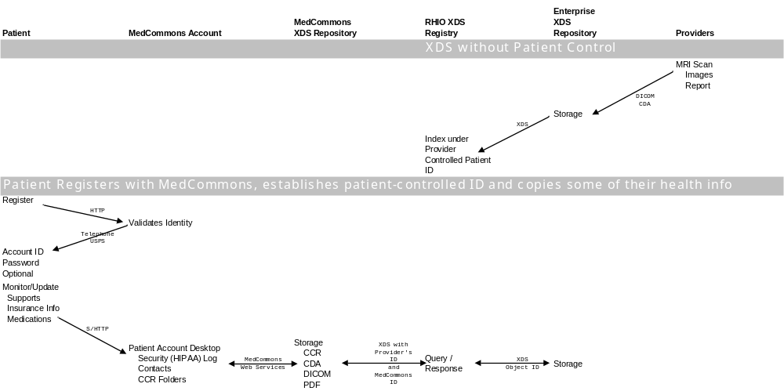

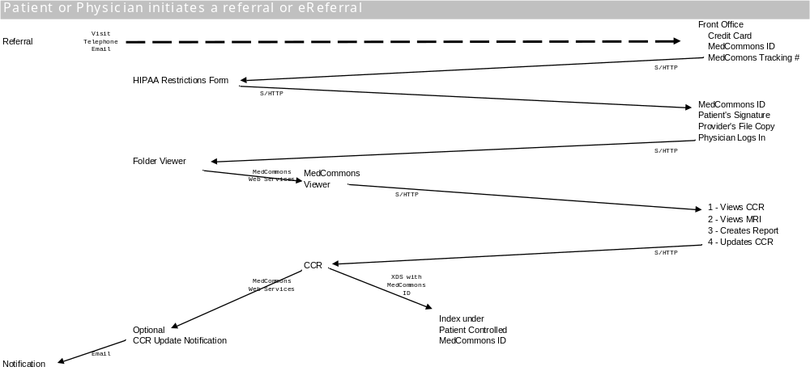

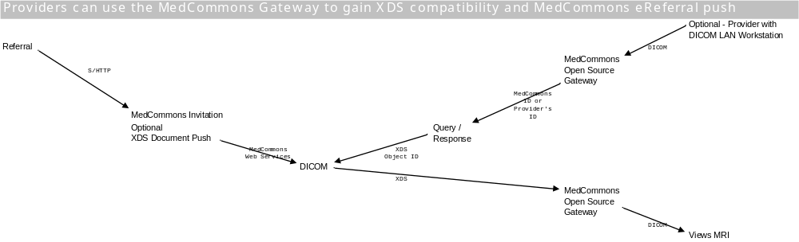


Patient Controlled Medical Records and eReferrals for Everyone

MedCommons is universally accessible to clinicians, patients and enterprises wherever they may be. New standards and open source software technology combine to facilitate referrals today even as they demonstrate a solid foundation for the National Health Information Network of tomorrow.

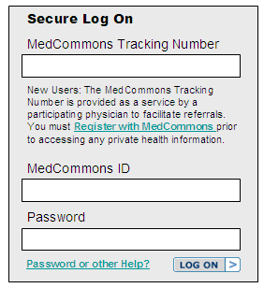
Register for your MedCommons ID
Privacy
About Us
FAQ
In the News
Personal Control of Medical Data
(Dr. Gropper’s Blog)
Join a Live on-line Demo of MedCommons
White Papers
Integration Profile
Local Gateway Log On



See us in action in the Cross-Enterprise Showcase at HIMSS Booth 6723 and MedCommons Booth 7370

The First Page is Always the Hardest

This is a first attempt at a home page for demo, web site and random MedCommons Gateways. Please ignore the graphic design as it will be redone by Ted, or the content as it will be redone by Dan, or the fact that this is a Word document as it will be managed by Keith, or the lack of functionality. A boy can dream. The Notes below are my attempt to organize the process.

Notes:
- This is the proposed MedCommons home page on the Web for both .net and .org. How soon can we actually put this up? What will be the process for managing content for testing and approval?
- This page can be the home page for our Enterprise Gateways starting with mcpurple06. Local Gateway Log On is dimmed above because it would actually be completely absent on the WAN. A LAN user that clicks this link would go to a gateway’s Selection Screen and see a bunch of DICOM studies. The Enterprise Gateway may require a local or domain login to get to this screen – MedCommons registration or connectivity is not required..
- Registration for a MedCommons ID will require a Credit Card and a working Phone Number along with the usual address and stuff. Users will be issued a 16-digit MedCommons ID (designed to look like a debit card number) on the spot. Their Password, but not their ID, will be communicated by telephone. (Eventually, we will offer to send their password by registered mail to get the Postal Service in the loop of identifying users.).
- People can change their Password and MedCommons ID. Changing the Password is free. Changing the ID may cost money.
- Users can check the Licensed Provider Box during Registration and provide a state and license number.
- A successful login that resolves to a single patient can result from entering a Tracking Number, a MedCommons ID, a HIMSS ID, and a Password. If the ID is a HIMSS ID no password is required. Otherwise, if the password fails, the User can continue in demo mode with demo data or return to enter the correct password. In all cases where a login resolves to a single patient, the CCR Folder Stack is displayed. This page replaces the current My Account page.
- Selecting a particular CCR Folder displays the WADO Viewer.
- A successful login for a provider that does not resolve to a particular patient shows the current My Account Page.
- A new field will be added to the top of the provider’s My Account Page:
Patient Credit Card Number
Print a Patient HIPAA Form >
- If the Credit Card number matches the one used by the patient in Registration, the Patient HIPAA Form includes the patient’s MedCommons ID and Name – ready to sign – and requests the provider to use the ID in all XDS submissions.

Pages with Dynamic Content

CCR Folder Stack

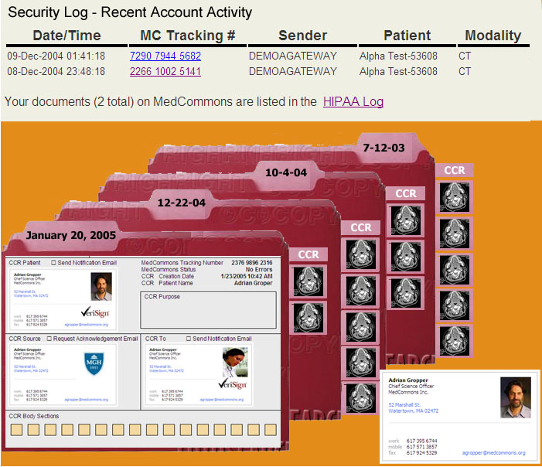

Notes:
- This is currently being worked on by Ted and Simon.
- A recent HIPAA Log section will be added to this screen since patients do not typically see the Selection Screen.
- At HIMSS the CCR Folder Stack is the result of the XDS Query. Replies that do not include a CCR will begin with PDF or CDA as appropriate.
- On the Web demo, the CCR Folder Stack will always return one dummy test folder.

Selection Screen

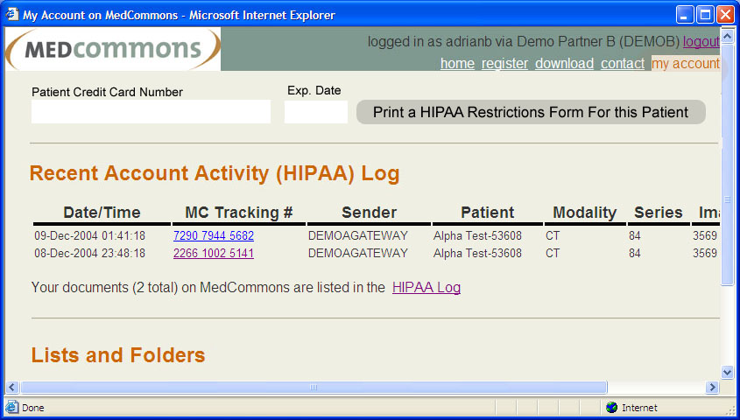

- This is currently called the My Account page. It is the default display for users who have checked off the Provider box.
- A link to the Gateway Download will be added. This does not have to be live for HIMSS or even in the weeks that follow.
- A block for entering the Patient’s credit card number will be added linking to the Patient HIPAA Form.

Patient HIPAA Form
- Most of the content of this form is supplied by the provider and branded by the provider. There is no official form that I’m aware of. School release forms are one page long. Doctor release forms can be 7 pages long. Most are somewhere in between. A more useful approach might be to assume that a practice has a written policy and a separate one page patient restrictions form. MedCommons would modify and print the restrictions form.
- A MedCommons section at the bottom includes the MedCommons Logo, Patient’s Name and MedCommons ID along with a directive requesting the inclusion of the MedCommons ID in all XDS filings.
- A Print button can be used by the provider to print the form for the patient to sign.
- A Sign and Connect to MedCommons button allows the patient to sign by entering their Password and sends the form to MedCommons as a CCR. A tracking Number is automatically generated for this transaction.
- As part of the Sign and Connect to MedCommons dialog above, the patient has the option of supplying the provider a previously generated CCR to save time and reduce the risk of introducing errors. This step would be unnecessary if the patient visit was preceded by am eReferral email invitation.

Frequently Asked Questions

- What is MedCommons?
MedCommons is a patient-controlled medical data bank. Like any bank, MedCommons depends on the trust of its customers to stay in business.
- Why call a bank MedCommons?
MedCommons reminds us all that there are many valuable uses for private medical data. This data belongs to the patient and only to the patient. It is the patient’s choice if and when arid how to share this data with physicians, insurance companies and various companies.
A commons is a resource managed in the common interest. Private medical data, properly managed can help to improve health care for all by facilitating scientific research, objectively demonstrating quality and by promoting public health arid safety.

In the movie “It’s a wonderful Life”, Jimmy Stewart teaches us about the value of banks to the community and the importance of voluntary participation in the bank as foundation for trust.
- Will my physicians accept and use MedCommons?
MedCommons is based on the physician’s own Continuity of Care Record standard. In the words of the ASTM standards organization:
The CCR, or Continuity of Care Record, is a standard specification that has been developed over the past two years jointly by ASTM International, the Massachusetts Medical Society (MMS), the Health Information Management and Systems Society (HIMSS), the American Academy of Family Physicians (AAFP), the American Academy of Pediatrics, the American Medical Association (AMA), the Patient Safety Institute, the American Health Care Association, the National Association for the Support of Long Term Care, and the Mobile Healthcare Alliance. The remarkable success in achieving widespread consensus and early sponsorship of the professional societies and organizations listed above (others are pending) is a testimony to the power and the timing of the concepts and the methodology supporting the CCR. This new specification is intended to foster and improve continuity of patient care, to reduce medical errors, and to assure at least a minimum standard of health information transportability when a patient is referred or transferred to, or is otherwise seen by, another provider.
- Will enterprises accept and use MedCommons?
MedCommons is a strong supporter of Integrating the Healthcare Enterprise Standards and a Participant in this year’s IHE Cross-Enterprise Showcase. The IHE process, manages a series of Profiles representing “best practices” for integration within enterprises and, with the recent Cross-Enterprise Data Sharing (XDS) Profiles, across enterprises.
MedCommons is certified by IHE as meeting the relevant IHE ITI –XDS Profiles.
Furthermore, MedCommons will release any of its software hosted by the enterprise under an OSI-certified Open Source license that enables everyone including providers and vendors to review, use, modify and embed the key components of IHE-XDS for free.
Relevant components of the MedCommons Gateway to the enterprise have already received clearance by the FDA.
- How will MedCommons make money?
MedCommons will provide eReferral transfer services and private medical data banking services to patients and their physicians.
MedCommons is free during the initial testing period. Even so, patient privacy and security is being maintained as mandated by the Health Insurance Portability and Accountability Act of 1996, Pub. L. 104-191 ("HIPAA").
- Referrals usually take days and cost plenty as I chase around town looking for films. Will MedCommons handle medical images such as CT and MR scans?
Yes. Please register and check out the demo.
MedCommons uses the CCR to organize referrals and links diagnostic-quality radiology images to the appropriate components of the CCR.
- CCRs and diagnostic radiology images sound like complicated and expensive technology. What will patients and physicians need to install on their computers?
Usually nothing. MedCommons is securely accessible to physicians and patients alike via modern Web browsers and email. This includes the ability to create and modify CCRs, scanned documents in PDF format and other formats required by XDS profiles.
Medical imaging facilities, hospitals and radiology practices that generate or process diagnostic medical images will be required to install the MedCommons Gateway or upgrade their systems to support IHE-XDS profiles required for patient control and cross-enterprise data sharing. The MedCommons Gateway is FDA-registered Free/ Open Source Software and will be available for free download once our pilot testing is complete.
- What is the relationship between MedCommons and the proposed National Health Information Network?
MedCommons is being offered as an open and standards-based solution to the patient-control component of the NHIN. We intend to work with Regional Health Information Organizations and other pilot programs as the NHIN takes shape.
- What is the relationship between MedCommons and proposed HSA (Heath Savings Accounts) and other consumer-directed care insurance programs?
MedCommons is independent of both health care and insurance providers. By providing true portability and world-wide access to health resources, MedCommons is well suited to consumer-directed insurance plans and may be offered as a convenient link to consumer-controlled health savings account payment cards.
- Will physicians have access to private data in my MedCommons account in case of emergency?
Only if you choose to allow it and to the extent required by law. MedCommons will make it easy to make copies of your private data and grant and revoke access privileges to those copies to physicians, family members and other people as you see fit.

User Registration Page

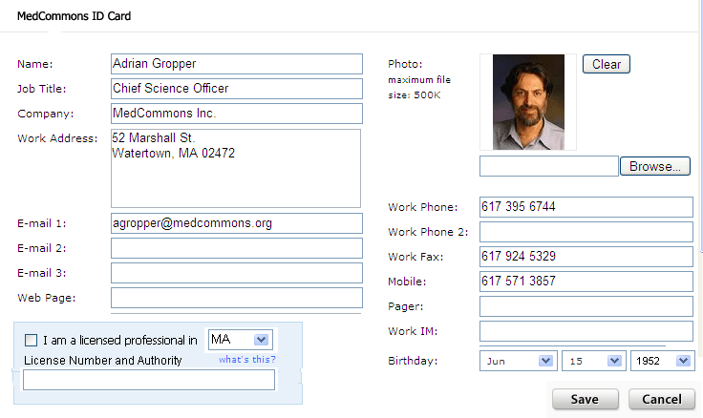

A valid credit card is required to complete your registration. A $5 fee will be collected to defer costs of issuing your secure MedCommons ID with telephone or US Postal service password delivery. If you cannot afford the registration charge or do not wish to provide MedCommons with credit card information, please send email to join@medcommons.org describing your circumstances and we will suggest alternative means of obtaining a MedCommons ID. Each family member requires their own MedCommons ID.

Although subsequent Password changes are free on line, requests for new MedCommons ID or changes to your credit card on file are subject to verification and will be charged $5 each time.

Proceed to Credit Card Payment ⇨

To save time filling forms, you can create MedCommons ID Cards for your current health care providers at no charge.
Create MedCommons ID Cards for your referral contacts ⇨

User Registration Forms
- This page should display the information being edited as a business card at the top. This card will be displayed on the CCR Folder Stack screen and used in the header of CCRs.
- A webcam will allow the patient’s photograph to be added to their card.
- Password changes are allowed but only after the initial (telephone or US Mail) communication.
- Linkage to Verisign or other strong and potentially biometric IDs will be allowed.
- A link on this page will allow patients to enter insurance, family support and physician information that can then be placed into their CCRs. MedCommons will check all incoming CCRs and alert the patient (email, telephone, at login) when CCR information (presumably from a provider) does not match any of the items they track in this section. The storage format of this patient controlled section is, of course, a CCR.

Credit Card Authorization

- Successful credit card authorization results in the user being issued a printable MedCommons ID that looks like a cross between a bank card and an insurance card. On the front, there is a 16-digit MedCommons ID Number, an expiration date 2 years in the future, and the person’s Name all in Caps to avoid confusion.

- The credit card authorization page also includes a field for entering a contact phone number (transfer the number from the ID card phone number) and an address for USPS mail also transferred from the ID card.

- If the patient has given us a valid email in their ID, they get an email with this information as well and instructions reminding them of how the initial password will be communicated.

- Messed up password authorizations will need to be handled by our 800-number which we will need to supply somewhere from the home page as well as here and on the ID card itself.

- The Credit Card number will be kept on file by MedCommons and used to pay for eReferral transfers and storage of large documents. Credit card charges will be indicated as a new column added to the user’s HIPAA log.

By way of documentation, this page at Digital River describes many of the features we need in our credit card processing beginning with low start-up costs. Our requirement for persistent credit card storage like Amazon One-Click or Expedia enter the last 4-digits may preclude us from using the DigiBuy service out of the box.

Telephone delivery of passwords is under investigation. Until it is available and integrated with our registration process a MedCommons Lifeline Demo / Support Link Person can call the user and deliver the password in a very robotic voice.

Live Demos and Lifeline Link Support will require administrator screens that can securely display Registration and other User sessions in progress. A secure administrator page will be located here.

Privacy
This is as close to a perfect privacy policy page as I’ve ever seen. Somebody who writes English better than I – or is it me - needs to edit this content by substituting MedCommons for Plaxo and little else. I also suggest we use our own signatures.

We need to license the use of Truste and Verisign logos.

In The News
Confidential News Embargoed until February 14, 2005
For Release: February 14, 2005

World’s First Independent Patient-Centric Medical Data Bank Unveiled

Revolutionary New Service Centralizes Personal Medical Information and Gives Control of Access to Patients

(February 14, 2005 Dallas, TX) At the Health Information Management Systems Society (HIMSS) Annual Meeting in Dallas, MedCommons Inc. launched a new product today that will forever change for better the way patients take responsibility for their own medical care. MedCommons Patient Data Bank, a new national patient-centric PHI storage and retrieval system marks a bold step in the evolution of healthcare. MedCommons isolates and controls the patient’s private health information as they make choices in hospitals and insurance plans in the same way that a bank account keeps private assets safe and secure. The MedCommons ensemble of technologies for independent and vendor-neutral patient information management introduces the industry’s first document gateway and diagnostic image viewer software to receive FDA clearance as Open Source Software.

Until now, proprietary medical records were inaccessible to the patient and an unreimbursed expense to the provider. Adrian Gropper MD, Chief Science Officer for the MedCommons Patient Data Bank, said, “The launch today of our national online service solves several age-old problems. First, it embraces portability. A patient’s complete medical history will now be easily accessible at the click of a mouse from our secure website (www.medcommons.net). Second, it is cost-effective. The patient pays only for banking their private information, while the provider enterprises purchase information technology as they would other infrastructure. Third, and most importantly, it separates the patient’s interest from the provider’s and puts the sum total of a person’s medical history and data in control of the patient, not managed health care.”

Technological advances in diagnostics, pharmaceuticals and minimally invasive techniques are stressing the ability of regulators and patients alike to cope with a flood of information and a growing range of choices. Comparing alternatives and getting the best advice requires that all of the relevant information be painlessly available to all of the physicians and caregivers that the patient might choose. Building on Integrating the Health Care Enterprise (IHE) best practices, MedCommons technology synchronizes standard PHI documents (DICOM, CCR, PDF) between providers and the PHI bank daily or on demand. Referrals and second opinions are as simple as paying a bill.

Bill Donner, CEO of MedCommons said, “In a dynamic and increasingly complex health care environment, MedCommons is uniquely independent. Think of the MedCommons Patient Data Bank as you would an online brokerage account. Very sensitive and private information is held securely by your broker, and similarly, by MedCommons. Only with your permission, can data be added or viewed.” Donner added, “Our business will succeed only if it keeps the trust of patients and physicians. Since we are neither a provider nor a payor, our success rests solely in our ability to protect the consumer’s privacy and self-interest.”

Curtis Cole MD, Director of Information Services Weill Medical College of Cornell University added “Doctors today understand the reasons to automate but rates of EMR adoption remain low. By separating the data from the application, MedCommons lets doctors control their practice and their practice technology - not the other way around. With MedCommons, referrals can be based on medical judgment with digital technology actually facilitating communication rather than adding another barrier.”

About MedCommons
MedCommons is a new company founded by experts in Internet-scale medical and financial software systems. Based in Watertown, MA, MedCommons offers the first nationally scalable standards-based network service that enables cross-enterprise and cross-system document sharing for both image and non-image based patient information. MedCommons has built an independent HIPAA compliant network supporting secure transfer and viewing of private information over the Internet. The service combines native Continuity of Care Record (CCR-standard) support with an FDA-cleared thin-client implementation of Web DICOM for universal access to diagnostic imaging.

For more information, contact: Judy Fallows, 617-395-6744 (jfallows@medcommons.org)
and visit www.medcommons.net

White Papers

IHE Integration Profile

I believe we’re eligible to post the IHE logo and post this certificate as a consequence of passing the Connectathon. Sean will tell us what goes in here in his spare time.

This page provides a poor description for the curious.

U.S. Patent Application No. : 60/550,030 SYSTEM AND METHOD FOR PATIENT CONTROLLED COMMUNICATION OF DICOM PROTECTED HEALTH INFORMATION March 19, 2004 Gropper et al.
US Patent Application No. 60/571,832 SYSTEM AND METHODFOR VIRTUAL RADIOLOGY AND PATIENT DOCUMENT FLOW May 17, 2004 Gropper et al.

